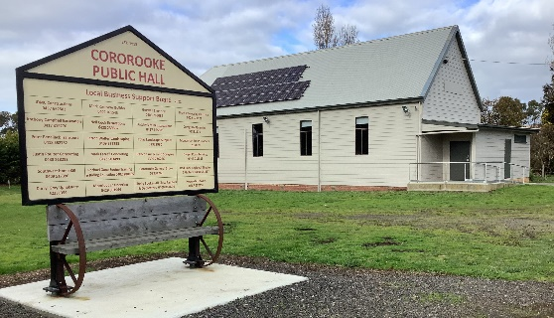
Cororooke Hall Market

Cororooke Hall
580 Corangamite Lake Road
Cororooke 3254

Saturday, ………………………….(insert date)Cororooke Market Trading: 10.00 – 2.00pm
Email this application to: justine.mccarthy@gmx.com.au 0436 352 717
Enquiries: Justine 0436 352 717 or Neil 0428 239 867,
Vendor Stall Application & Information

Name of Business / Vendor …………………………………………………

Name of Representative ……………………………………………………………

Phone--- ………………….. Mobile ……………………………………………

Email---- ……………………………………………………………………………………
Please tick the following details:
Powered site required (indoor or outdoor - limited availability)
X ...Copy of Public Liability insurance Certificate of Currency for the amount of $10,000,000 is included with this application
▪
OR
Outdoor Stall $20 - Outdoor vendors need to provide their own shelter
Outdoor Stalls with Power $25 (limited no. available)
Indoor Stall $25

Cheque payable to ‘Cororooke Hall’
OR
I have paid by Direct Debit to (NAB) BSB: 083-585, Account: 51-573-9090
Please reference ‘Market and your stalls name’ to identify your payment
Double check the bank details above before sending your payment.

I am a Food & Drink Stall holder and I have registered on "StreatTrader" (streatrader.health.vic.gov.au) (the Shire now requires that we obtain a copy of your insurance)

I, (PRINT NAME) ………………………………, have read the above information regarding vendor stall.

Signed: ………………………………… …… / ……. / …202……..
Council now requires that we obtain a copy of your insurance
Also if you are selling edible items you need also to notify the Colac Otway Shire that you have a stall at this market – phone 5232 9400 & ask for Environmental Health team will will assist you

